Java Script Complete Notes

Variables:
Think of variables as containers to store data.
JavaScript provides 3 ways to create variables:
var
let
const

- var
==========
var is the old way (before ES6).
Var can be Re-declared and Re-assigned
Re Declared
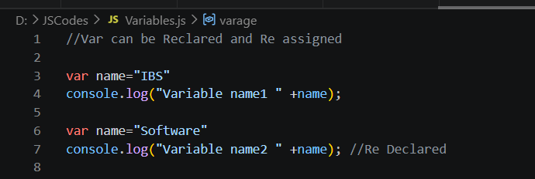
Op: Variable name2 Software
//Re assigned
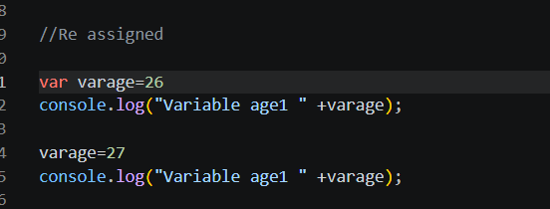
Variable age1 27
Var is a Function Scope not a block Scope
Declared inside the function and printing inside the Function as well
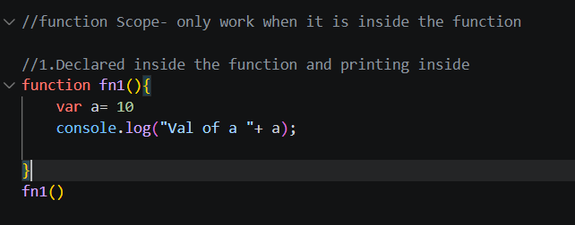
Val of a 10
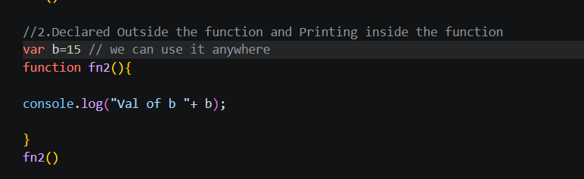
Val of b 15
We can use b anywhere

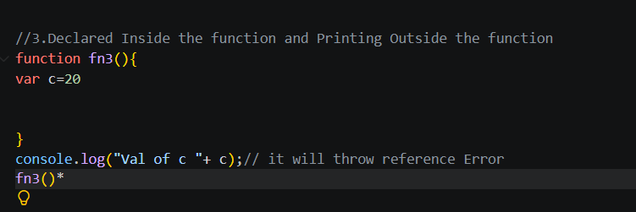
Op: ReferenceError
//Problem with var
//Inside blocks (if, for, while) it is NOT block scoped.

2.Let:
=======
Introduced in ES6.
It fixes the problems of var.
Can be Re assigned
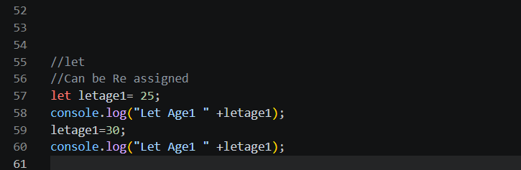

Let Age1 25
Let Age1 30

Cannot be Re Declared
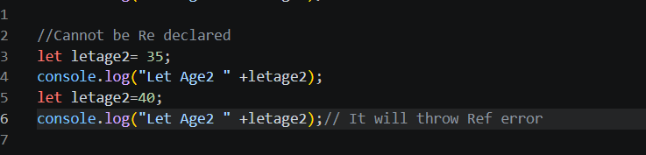
SyntaxError

Let is a Block Scope
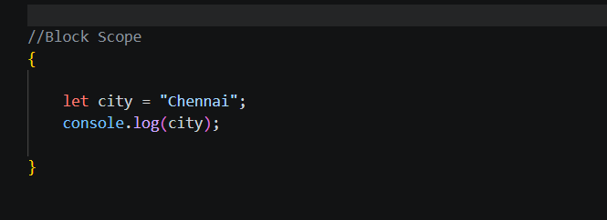
Chennai
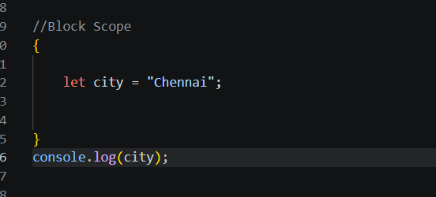
Reference Error

3.Const
Used for values that should not be reassigned.
========

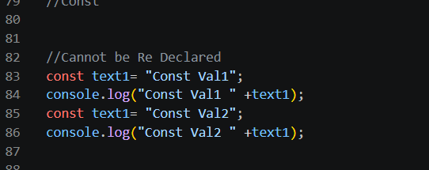
SyntaxError
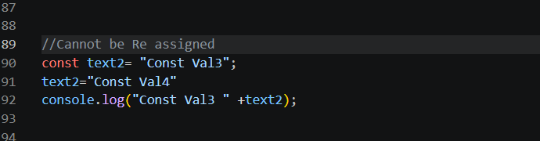
TypeError

Similar to let. Const also a Block scoped not function scoped

Array and object Examples
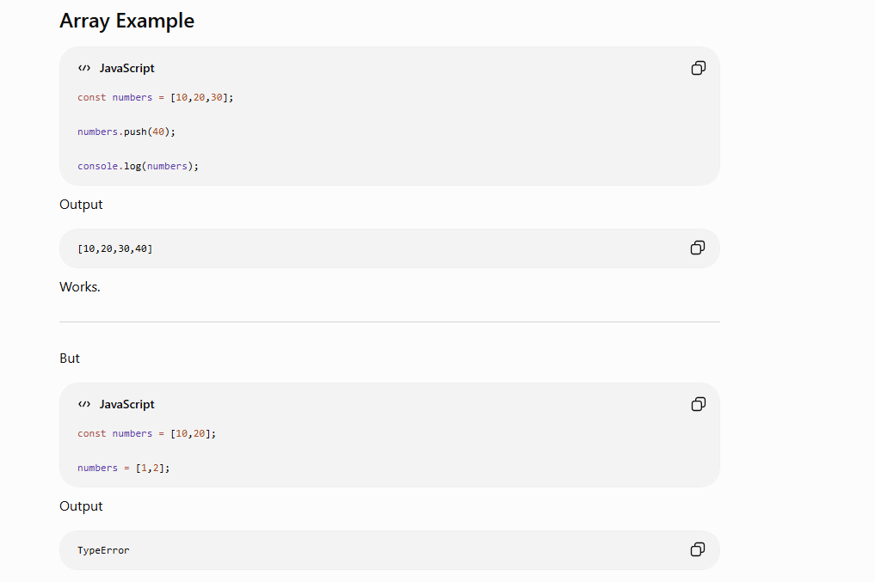
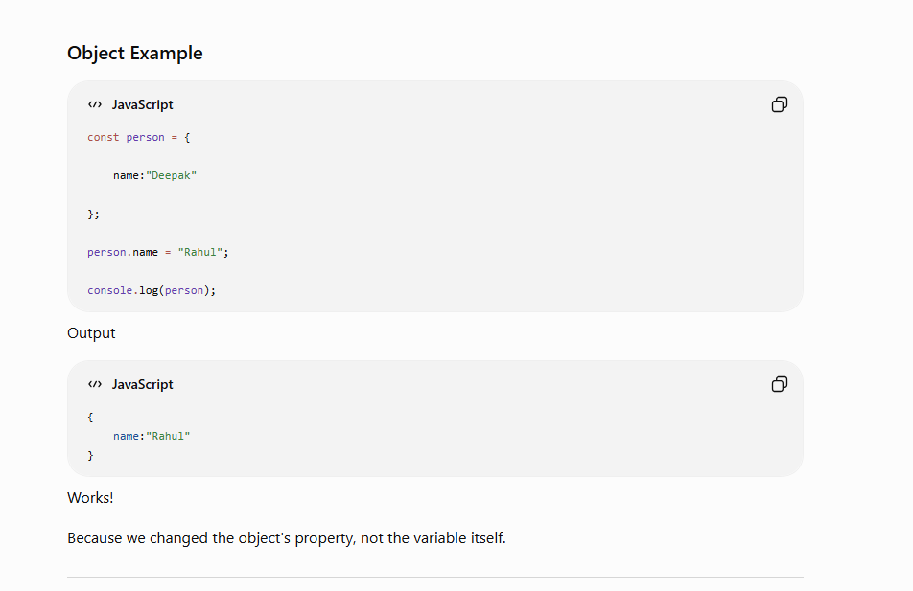
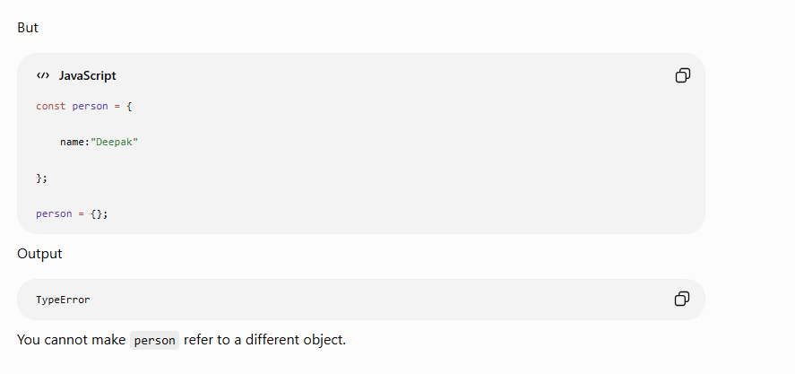

Function Scope and Block Scope
=====================================
Function Scope | Block Scope
Scope created by a function | Scope created by { } (block)
var is function scoped | let and const are block scoped
Variable exists throughout the function | Variable exists only inside the block

A variable declared with var inside a function is available everywhere inside that function, even if it is declared inside an if or for block.

Because var ignores the block (if, for, while) and belongs to the entire function.
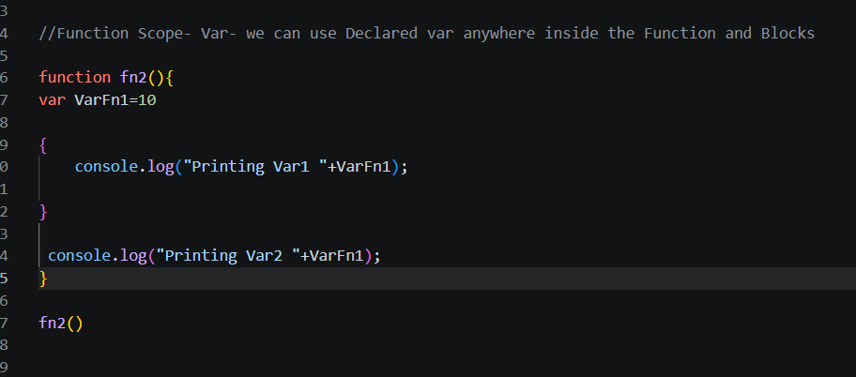

Block Scope
A variable declared using let or const belongs only to the block {} where it is declared.
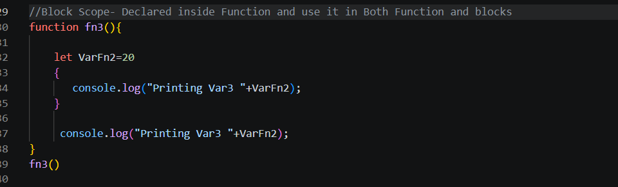
Printing Var3 20
Printing Var3 20

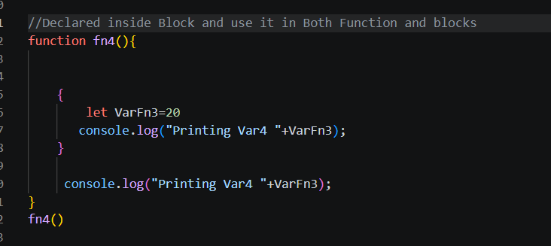
Printing Var4 20
ReferenceError
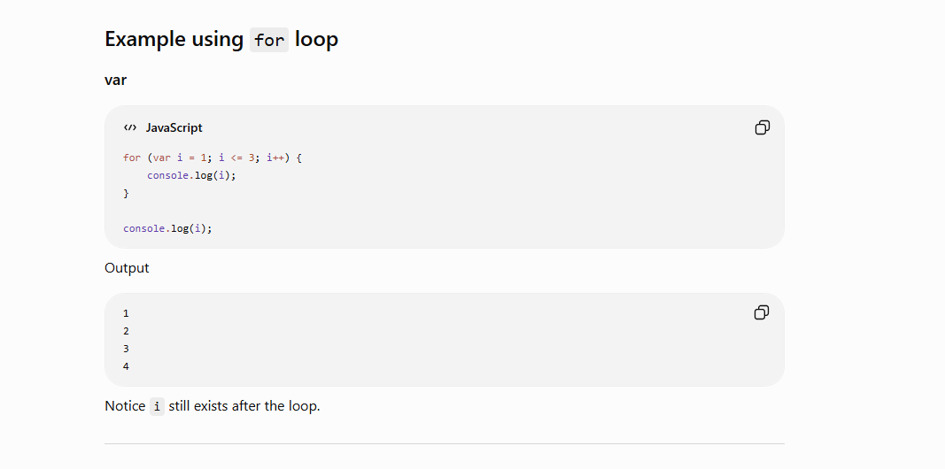
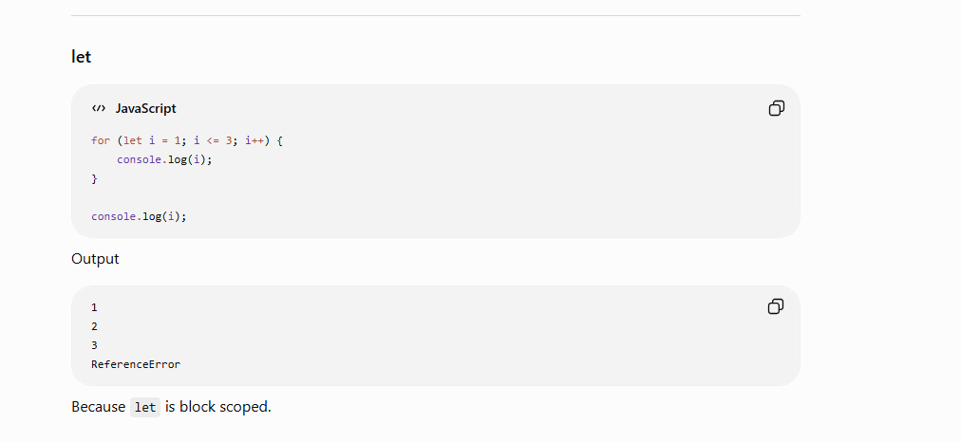

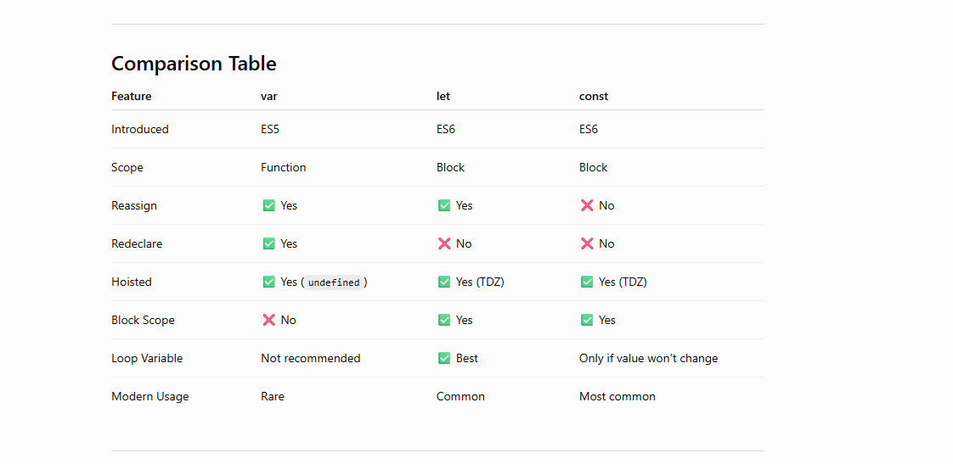

Types of Errors in JavaScript
There are mainly 7 common types of errors:
- SyntaxError
Missing Bracket/ Missing Paranthesis/ re declaring let/ const
- ReferenceError - console.log(name); before declaration trying to print (Occurs when JavaScript cannot find a variable or function.)
- TypeError - Occurs when you perform an operation on a value of the wrong type.
- RangeError - Occurs when a value is outside the allowed range.( let arr = new Array(-5);)
- URIError -
- EvalError (rare)
- AggregateError (ES2021)
- Run Time Errors
- Logical Errors

Functions:
A function is a reusable block of code that performs a specific task.
Instead of writing the same code again and again, you write it once inside a function and call it whenever needed.

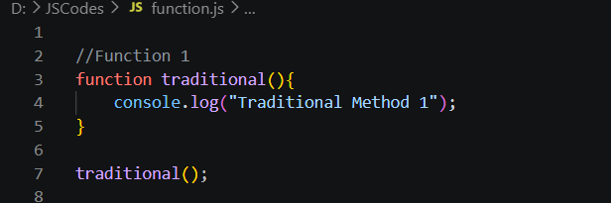

With Single parameters
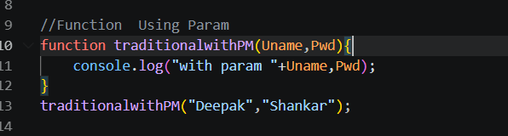

Return value
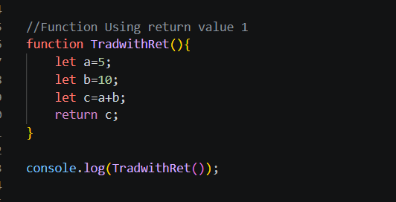

Return value with params

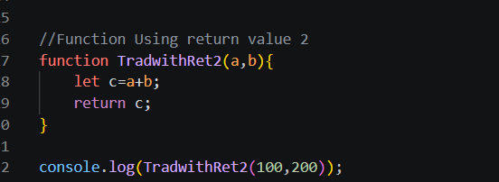

Returning with Multiple values
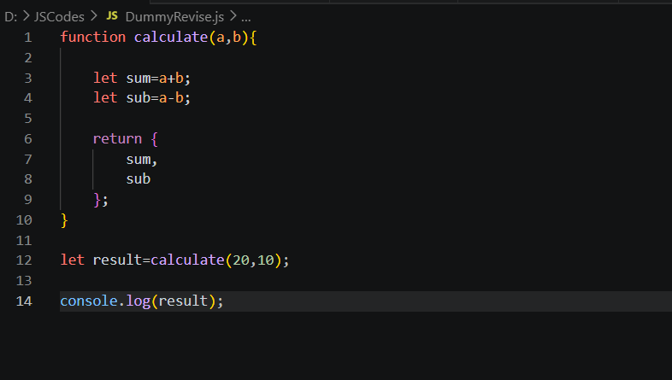

We can store function in variables as well
This is similar to Let, const ,var declarations

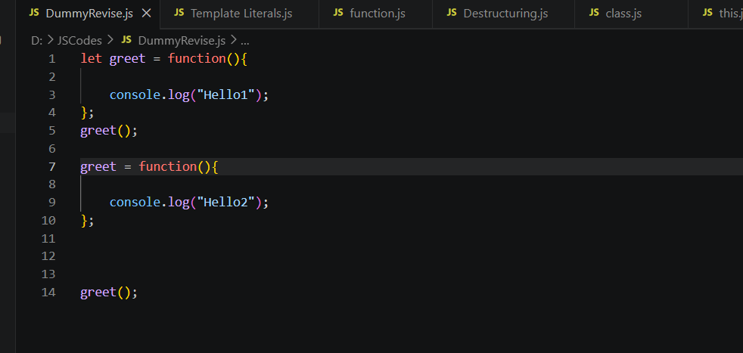

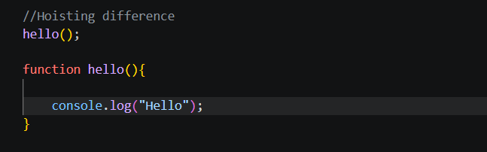
Works because declarations are hoisted.

Hoisting using declarations
ReferenceError

Arrow Functions Declarations and Examples
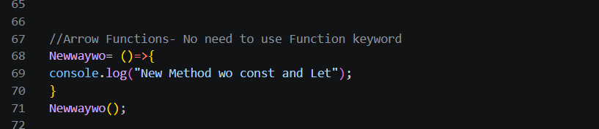
() => is mandatory because there are no parameters.
Storing in variables
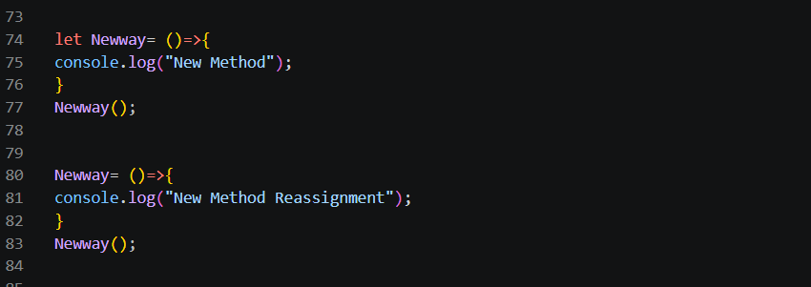
With parameters
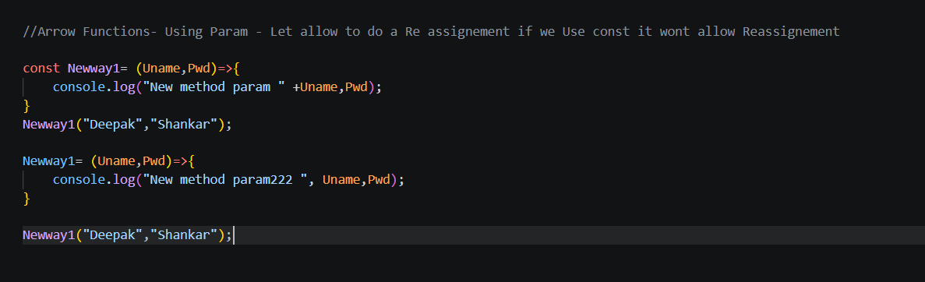

Parentheses examples
Because when we use curly braces {}, JavaScript treats it as a function body, and we must explicitly write return.
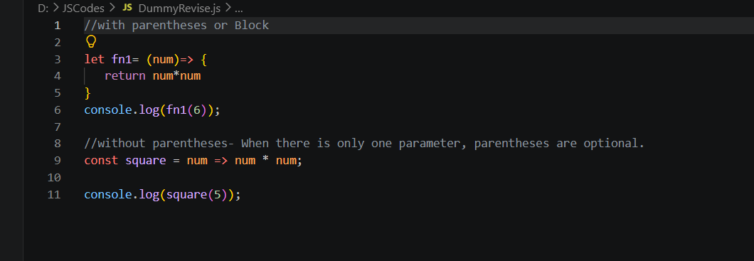
Use Normal Function
- Object methods
- Constructors
- When you need your own this
- When using new

Use Arrow Function
- Callbacks
- Short utility functions
- Array methods
- Promise callbacks
- Async functions
- Playwright tests

Interview Question
Which one should I use?
Use arrow functions for:
- ✅ Callbacks
- ✅ map()
- ✅ filter()
- ✅ forEach()
- ✅ Promises
- ✅ async/await
- ✅ Playwright tests
Use normal functions for:
- ✅ Constructors
- ✅ Object methods that use this
- ✅ When you need the arguments object
- ✅ Function declarations that should be callable before they're defined

Call Back Function
A function that is passed as an argument to another function, and is executed later.
==================================

Complete the Function work first then it will proceed the Callback function
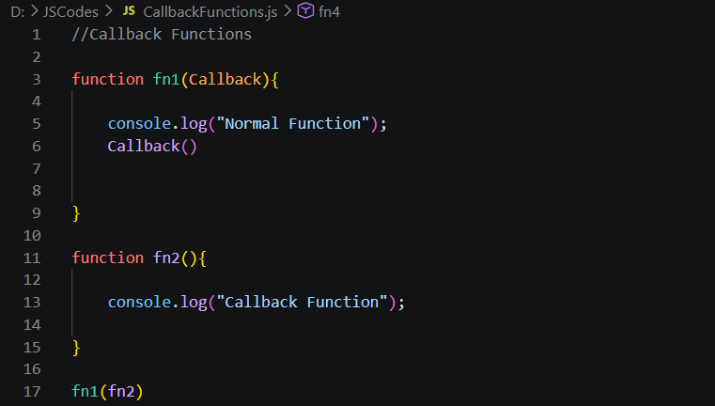

Using params

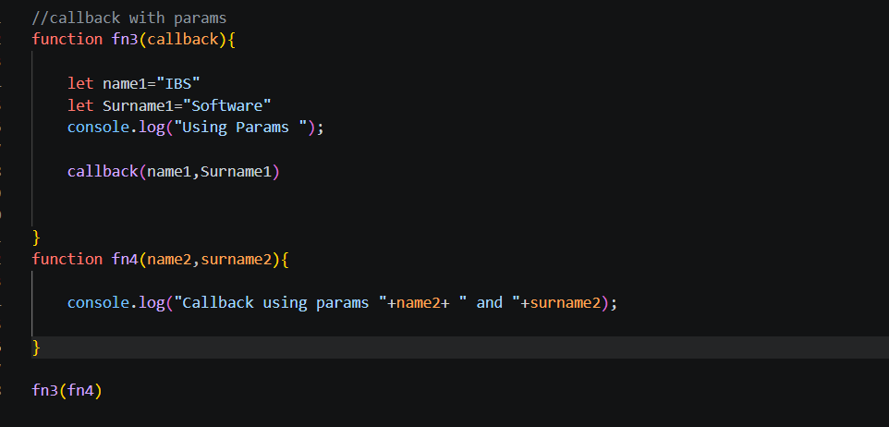

“ Holding Callback as of now “

Conditional Statements
A conditional statement checks a condition and executes different blocks of code depending on whether the condition is true or false.

Types of Conditional Statements
- if
- if...else
- else if Ladder
- Nested if
- switch
- Ternary Operator (? :)

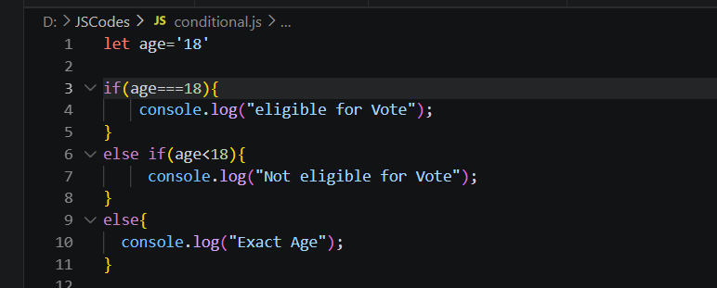

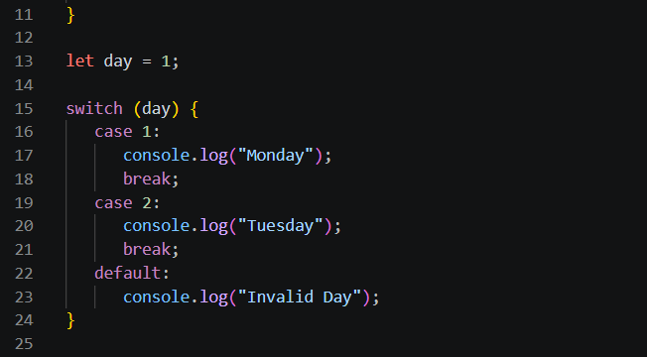

break stops the switch.
Without break, execution continues into the next case (fall-through).

When there is No break
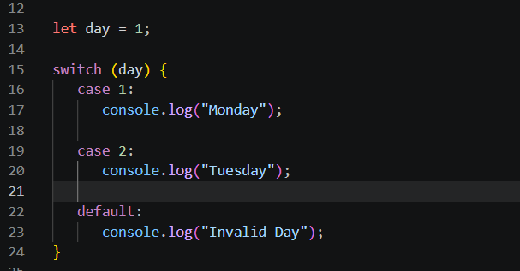
OP:
Monday
Tuesday
Invalid Day

Ternary Operator
Short form of if...else.
Syntax:
condition ? value1 : value2;
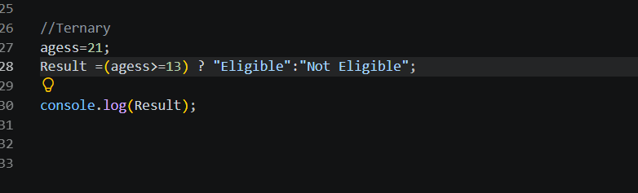
let age = 21;

age >= 18
?
console.log("Eligible")
:
console.log("Not Eligible");

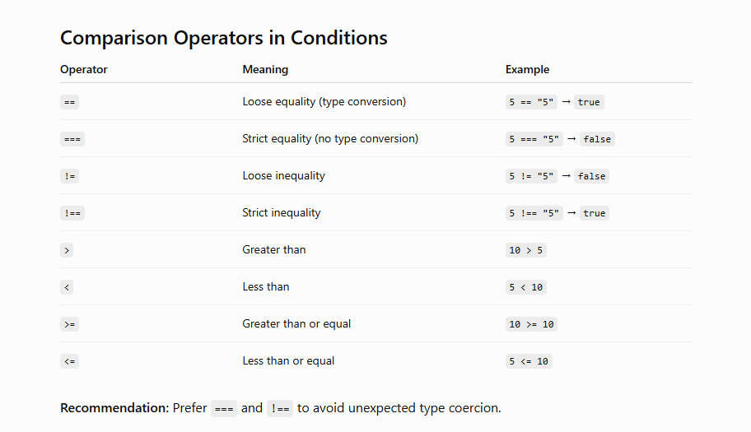

Logical Operators
&& - And
|| - OR
! - Not

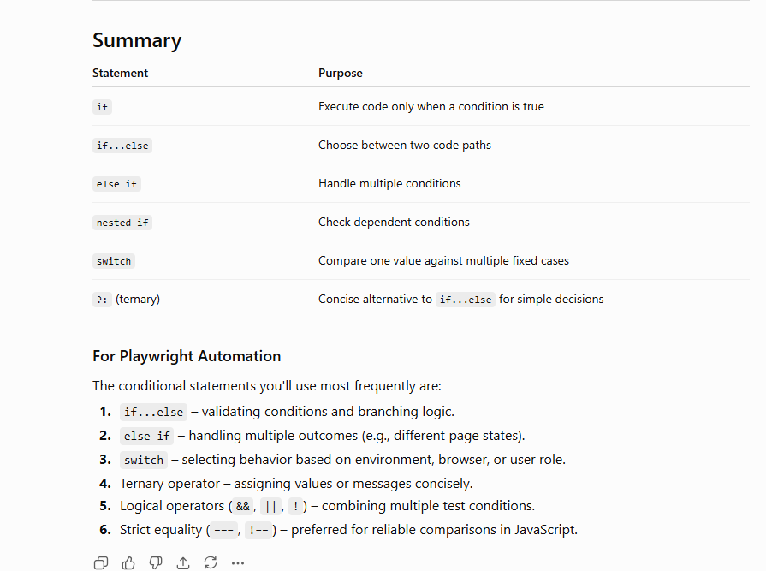

LOOPING:
Loops are used to execute a block of code repeatedly until a condition becomes false.
Instead of writing the same code multiple times, we use loops.
Types of Loops in JavaScript
JavaScript provides several looping statements:
- for
- while
- do...while
- for...of
- for...in
- Array.forEach()

While Loop
The while loop executes as long as the condition is true.
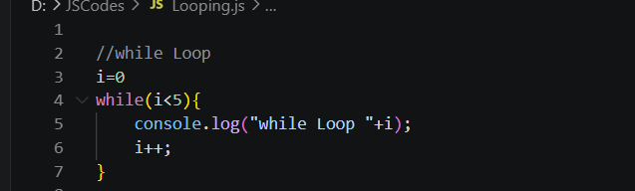

while Loop 0
while Loop 1
while Loop 2
while Loop 3
while Loop 4

Using break- Immediately stop the Loop
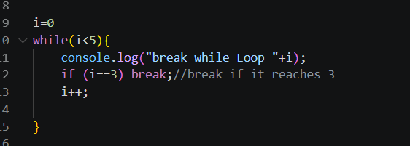
break while Loop 0
break while Loop 1
break while Loop 2
break while Loop 3

Using Continue- It will skip the Current iteration
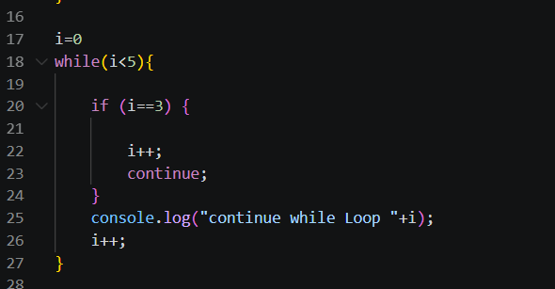
continue while Loop 0
continue while Loop 1
continue while Loop 2
continue while Loop 4

Do while
The do...while loop executes the code at least once, even if the condition is false.
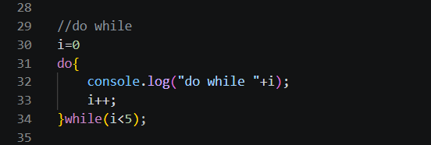
do while 0
do while 1
do while 2
do while 3
do while 4
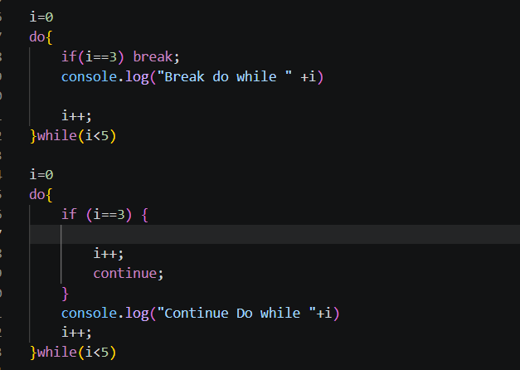
Break do while 0
Break do while 1
Break do while 2
Continue Do while 0
Continue Do while 1
Continue Do while 2
Continue Do while 4

Even though the condition is false, the loop runs once because the condition is checked after executing the block.
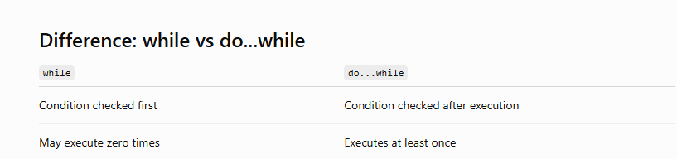

For Loop
The for loop is the most commonly used loop in JavaScript.
We can use both break & continue
We can access arrays(array values not index) not objects
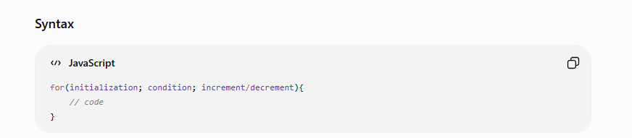
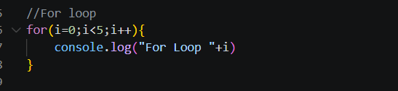
For Loop 0
For Loop 1
For Loop 2
For Loop 3
For Loop 4

For of
Used to iterate over Iterable objects like arrays and strings.
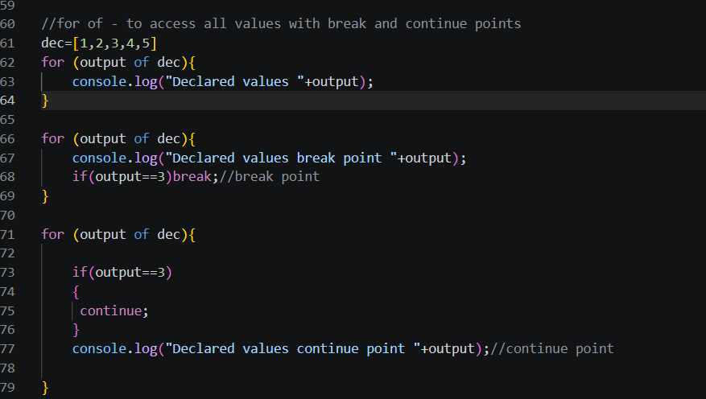

Declared values 1
Declared values 2
Declared values 3
Declared values 4
Declared values 5

Declared values break point 1
Declared values break point 2
Declared values break point 3

Declared values continue point 1
Declared values continue point 2
Declared values continue point 4
Declared values continue point 5
Using string
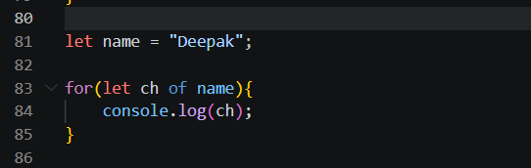
D
e
e
p
a
k

For in
Used to iterate over object keys (property names).
To print values
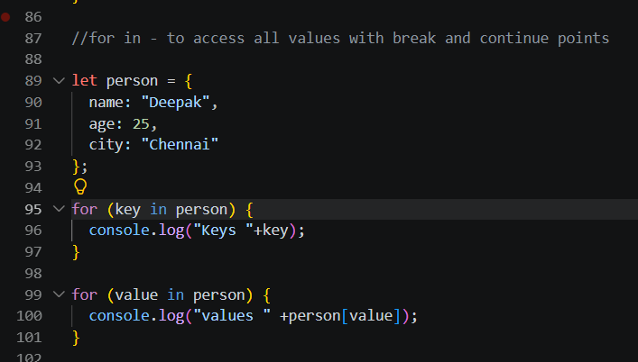

Keys name
Keys age
Keys city

values Deepak
values 25
values Chennai

Print both Key and Value
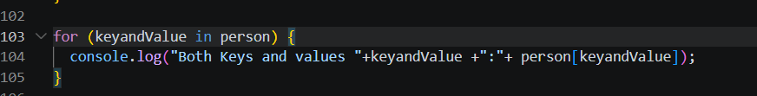

Both Keys and values name:Deepak
Both Keys and values age:25
Both Keys and values city:Chennai

Using break and Continue
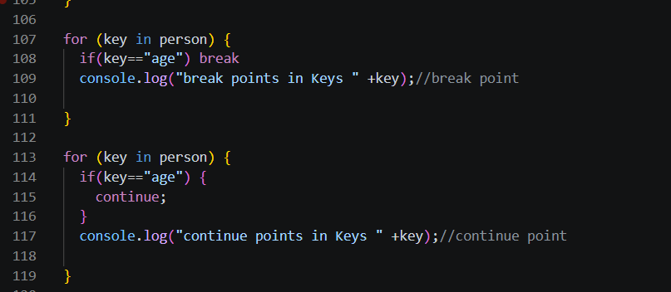
break points in Keys name
continue points in Keys name
continue points in Keys city

if we try to access array using For in
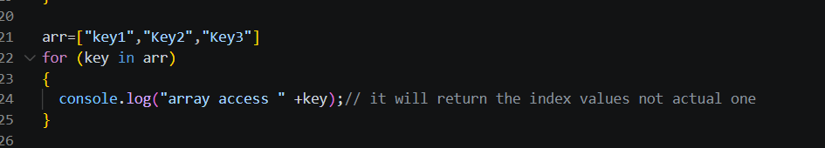
array access 0
array access 1
array access 2

For Each
forEach() is an array method that executes a callback function once for each array element.
To access all values in arrays
Cannot use break and Continue
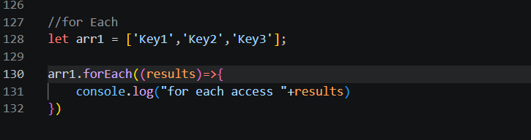
for each access Key1
for each access Key2
for each access Key3

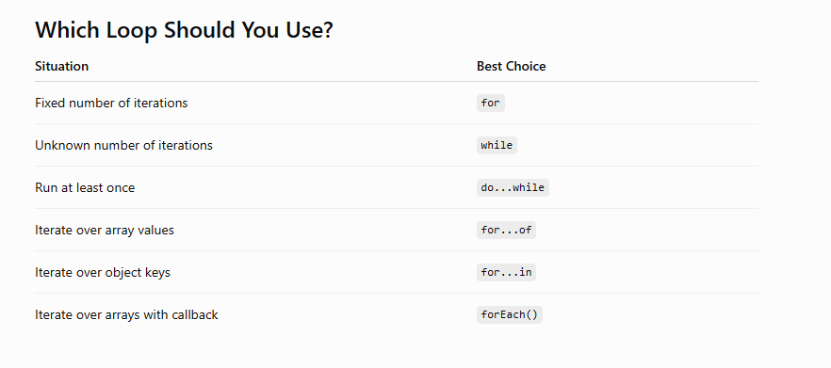

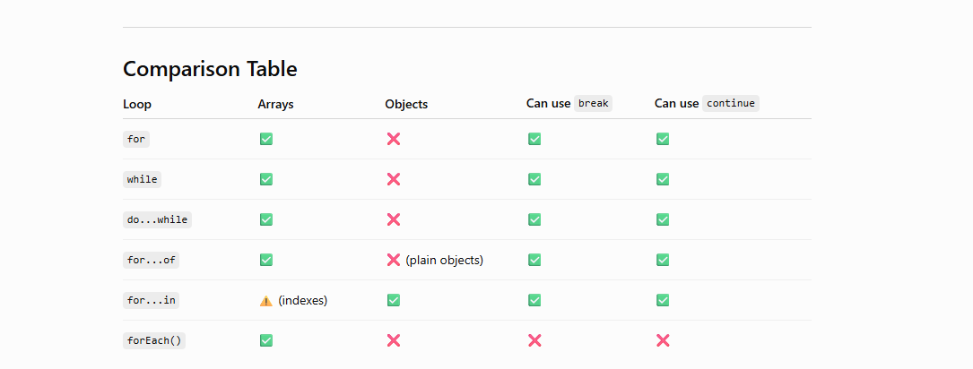

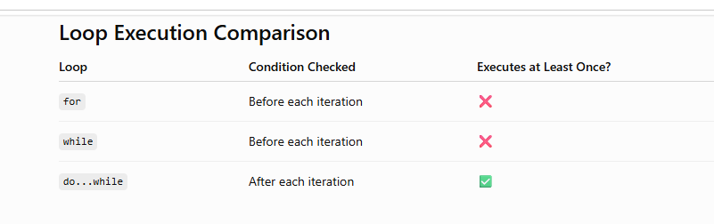

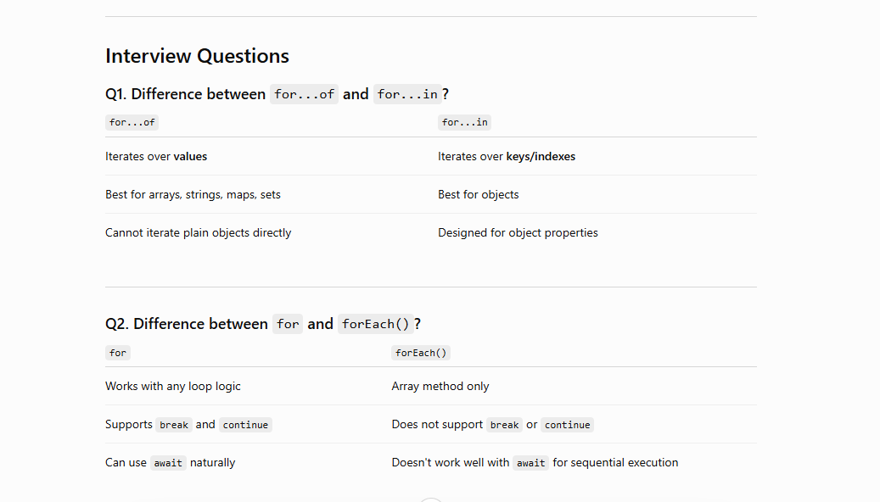

Error Handling:

If the Errors does not handled properly then the code stops immediately
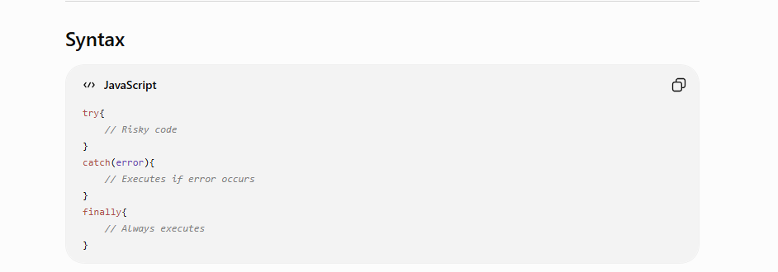
Below code throw error
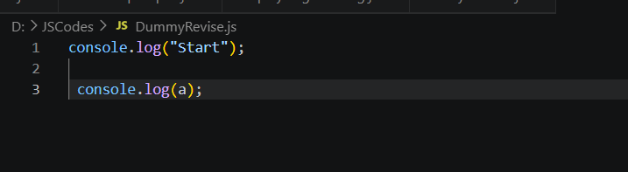
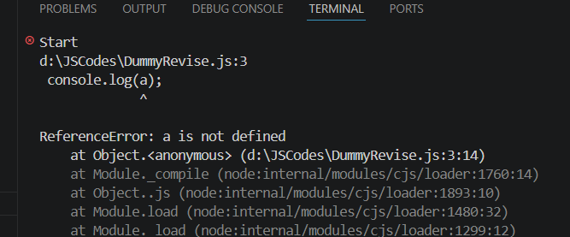

After Handling Errors in catch block
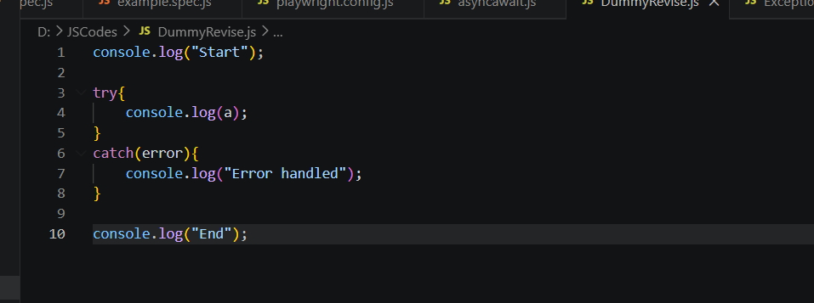
Try:
The try block contains code that might produce an error.
Catch:
Handles the exception.
Finally:
The finally block always executes.
throw Statement
we can create our own errors.

Error types
error.name- Ex : ReferenceError
error.message- Ex: a is not defined
error.stack- Shows where the error happened.
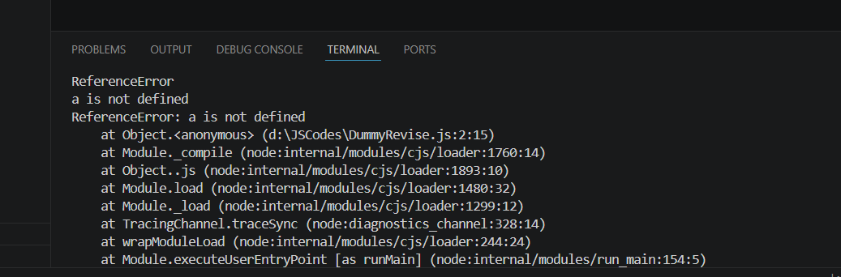

We can create our Own Errors
  - If No Error has been thrown then manual error get printed in Catch block
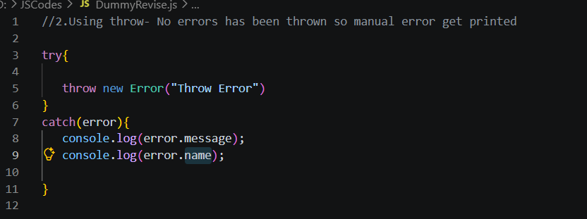
Message: Throw Error
Error name: Error

  - Error has been thrown so manual error get ignored
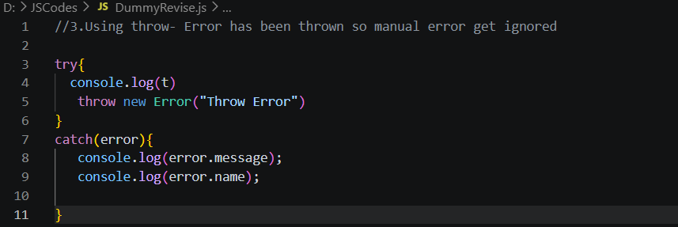t is not defined
ReferenceError

  - We can specify names to the Declared Error
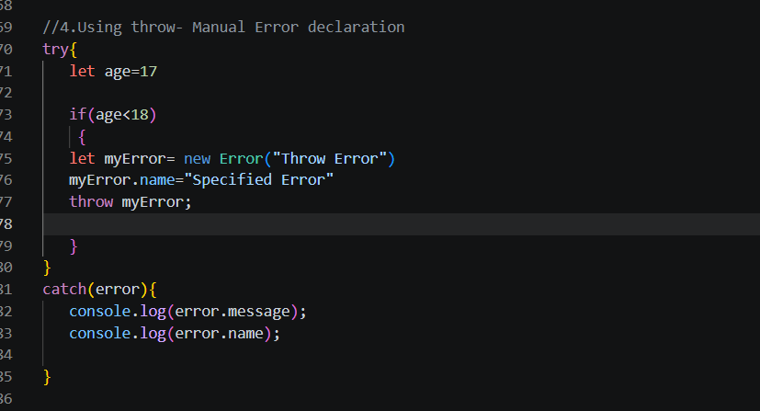
Messge: Throw Error
Name: Specified Error

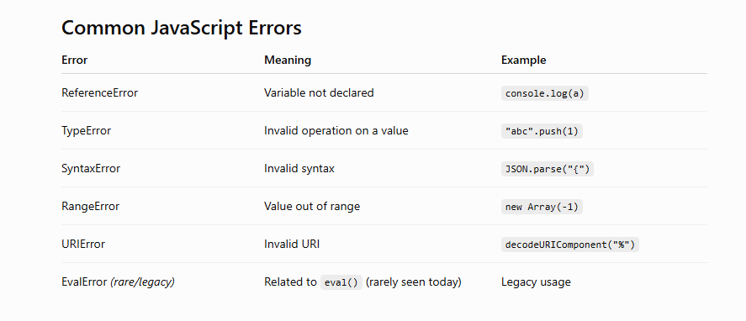

Arrays
An Array is a special object used to store multiple values in a single variable.
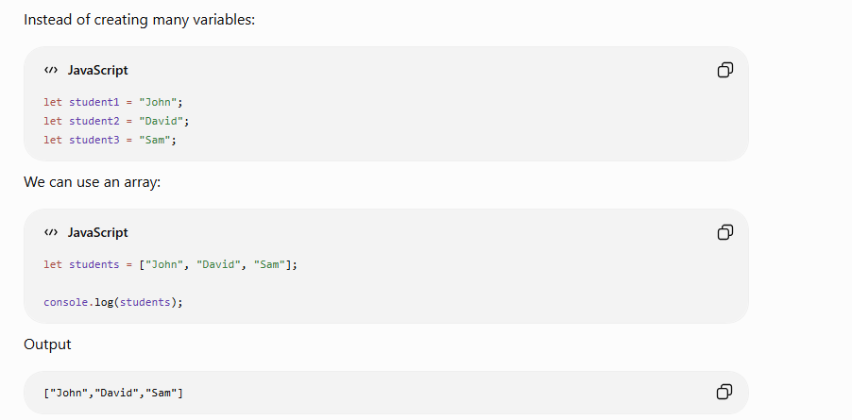
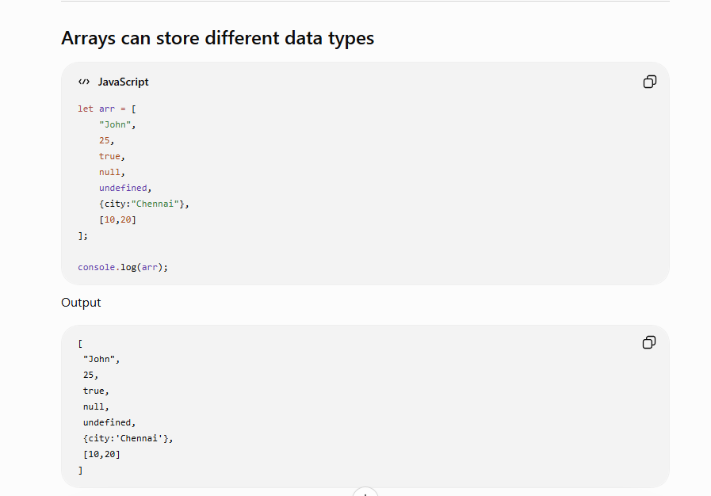
Index
0 1 2 3
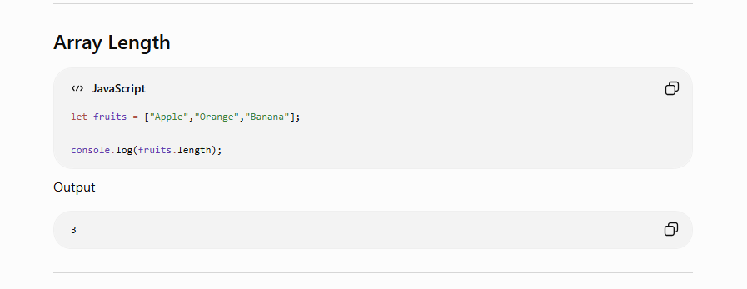

Printing array
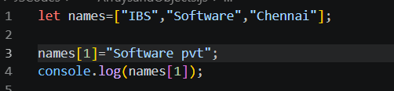
Software pvt

Re assign and print since it is let
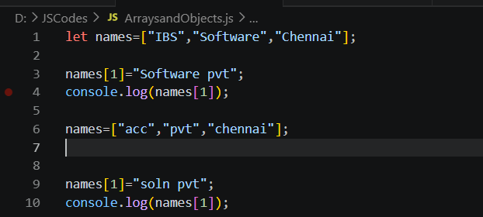
soln pvt

Using For each loop we can access all values in arrays
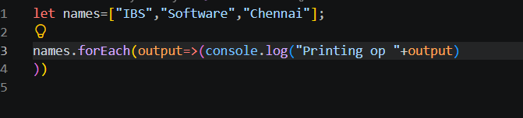
Printing op IBS
Printing op Software
Printing op Chennai

Array Methods
1. push()
Adds one or more elements to the end of an array.
let number=[1,2,3,4]
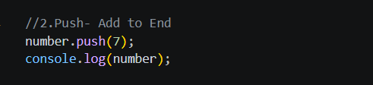
[ 1, 2, 3, 4, 7 ]

2. pop()
Removes the last element.
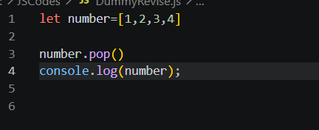
[ 1, 2, 3 ]

3. shift()
Removes the first element.
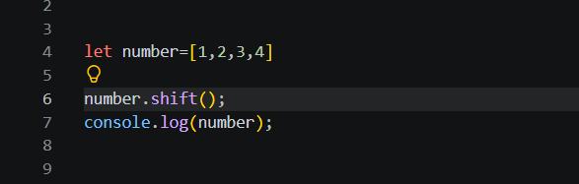
[ 2, 3, 4 ]

4.unshift()
Adds elements at the beginning.
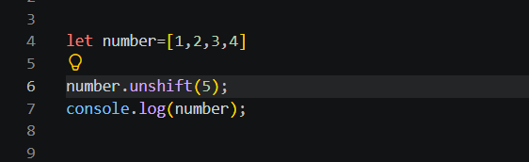
[ 5, 1, 2, 3, 4 ]

5. map()
Transforms every element.
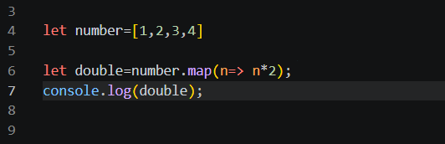
[ 2, 4, 6, 8 ]
‘using return
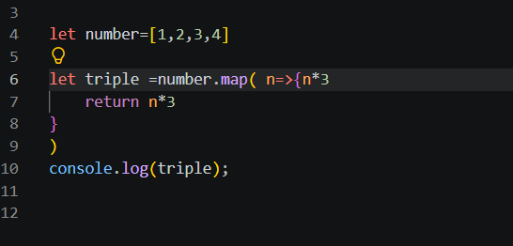
[ 3, 6, 9, 12 ]

6. filter()
Returns only matching elements.
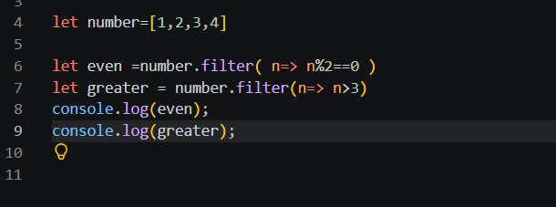

7.find()
Returns first matching element using given conditions
Stops searching after finding the first match.
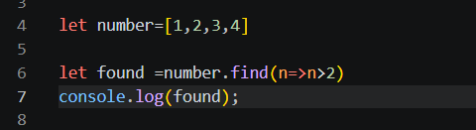
3

8.findIndex()
Returns index.
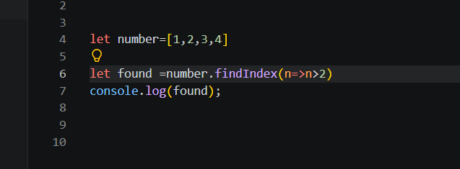
2

If not found: Return -1
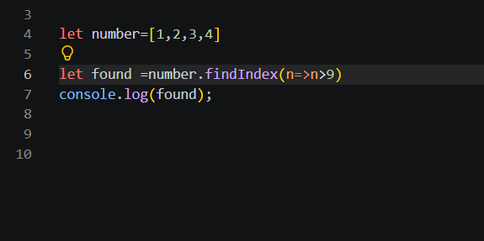
-1

9.Some()
Returns true if at least one element satisfies condition.
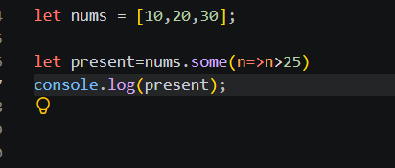
True
10. every ()
Checks if all satisfy condition.
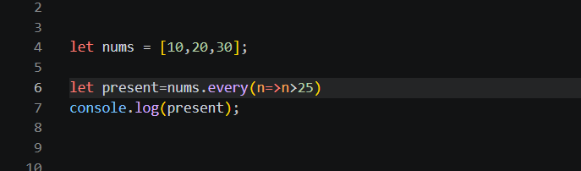
False

11.reduce()
Converts array into single value.
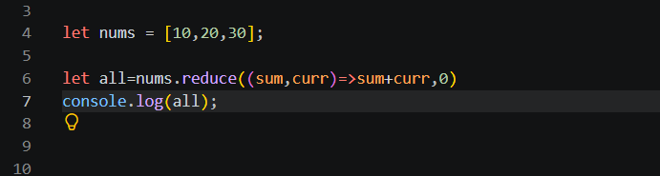
60

12. includes()
Checks whether value exists.
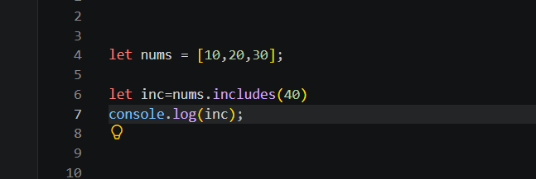
False

13.Indexof
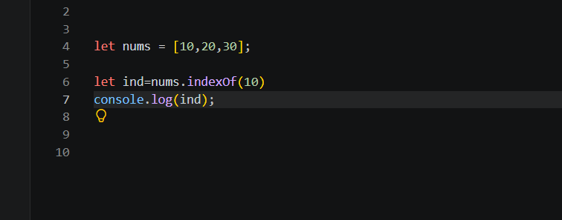
0
If not found return -1
14.sort()
Sorts array.
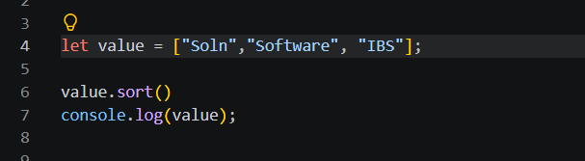
[ 'IBS', 'Software', 'Soln' ]

Using numbers Ascending and descending
Ascending (By default)
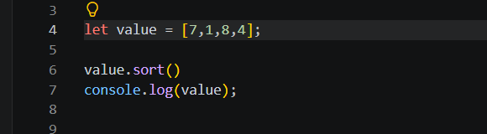
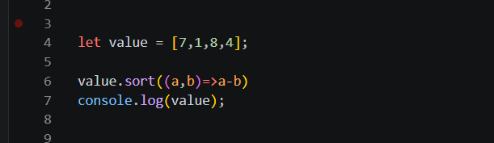
[ 1, 4, 7, 8 ]
Descending
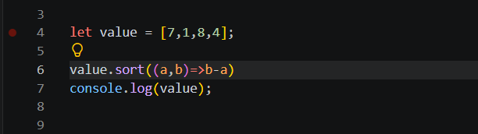
[ 8, 7, 4, 1 ]
15.Slice
Copies part of an array.
Original array remains unchanged.
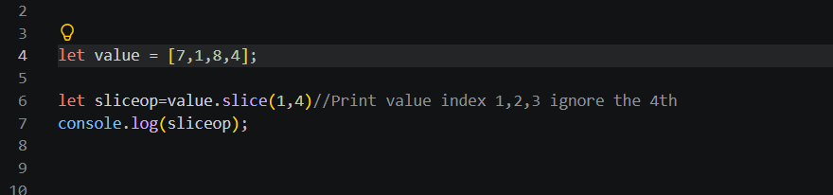
[ 1, 8, 4 ]
To copy all
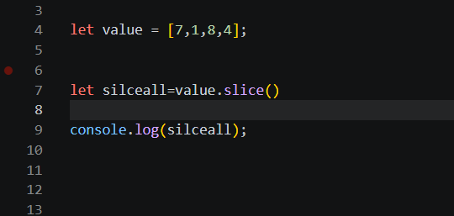
[ 7, 1, 8, 4 ]

16.Splice()
Used to
- Insert
- Delete
- Replace
Changes original array.
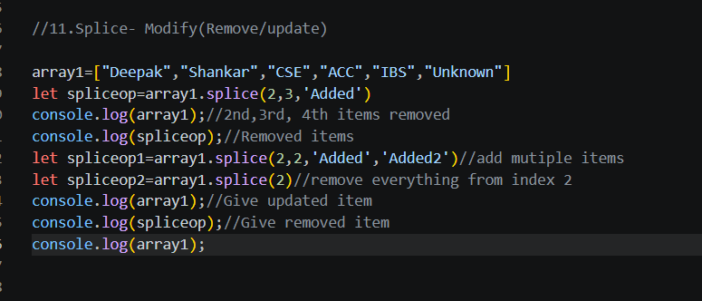
[ 'Deepak', 'Shankar', 'Added', 'Unknown' ]
[ 'CSE', 'ACC', 'IBS' ]
[ 'Deepak', 'Shankar' ]
[ 'CSE', 'ACC', 'IBS' ]
[ 'Deepak', 'Shankar' ]

17.For each()
Used for looping.
Cannot use break or continue.
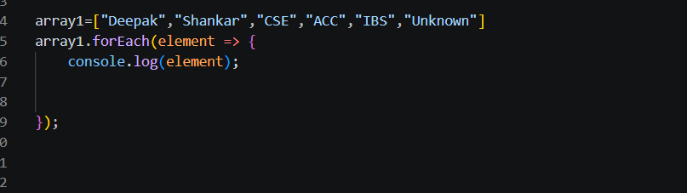

Deepak
Shankar
CSE
ACC
IBS
Unknown

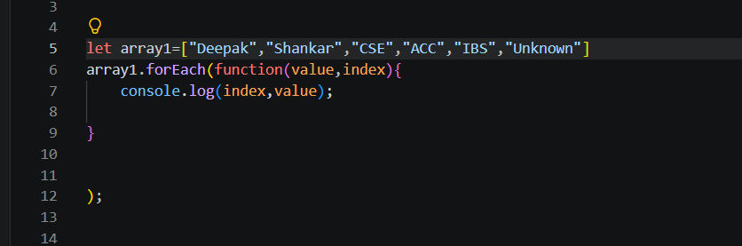
0 Deepak
1 Shankar
2 CSE
3 ACC
4 IBS
5 Unknown

18.for in
Loops through values.
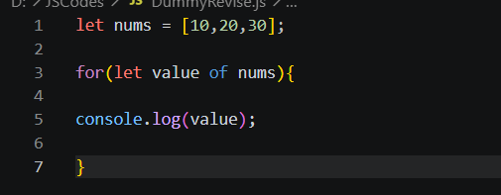
10
20
30
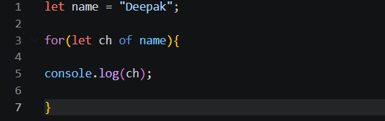
D
e
e
p
a
k

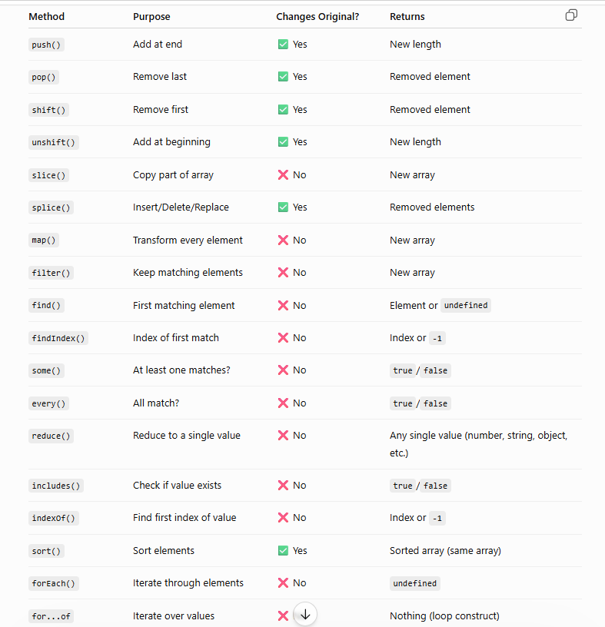

Objects
An object is a collection of key-value pairs.
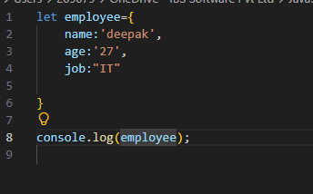
{ name: 'deepak', age: '27', job: 'IT' }

Printing One value:
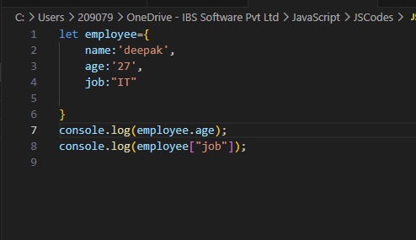
27
IT
To add new key and value
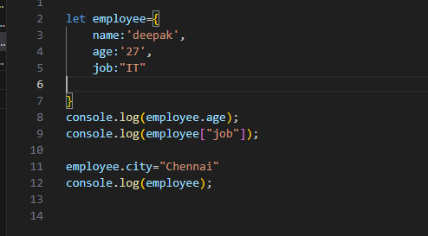
{ name: 'deepak', age: '27', job: 'IT', city: 'Chennai' }

Object Using Different Data-types
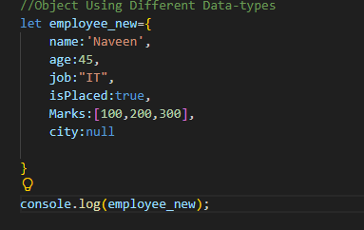

Objects inside Objects
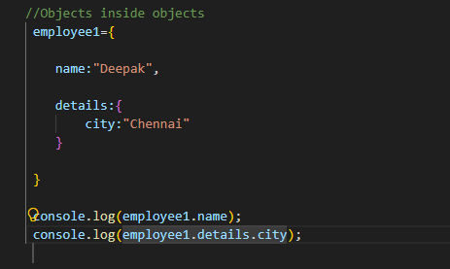
Deepak
Chennai

Objects inside array
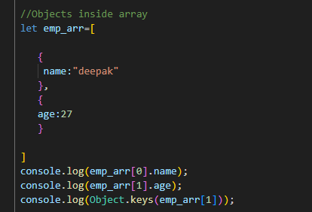
deepak
27
[ 'age' ]

Objects inside objects
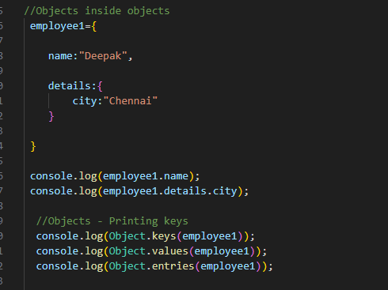

Deepak
Chennai
[ 'name', 'details' ]
[ 'Deepak', { city: 'Chennai' } ]
[ [ 'name', 'Deepak' ], [ 'details', { city: 'Chennai' } ] ]


True

Seal
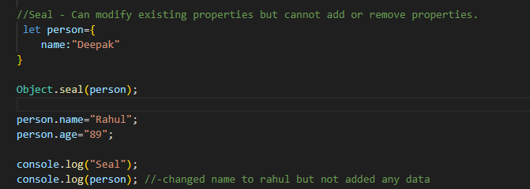
{ name: 'Rahul' }

Freeze
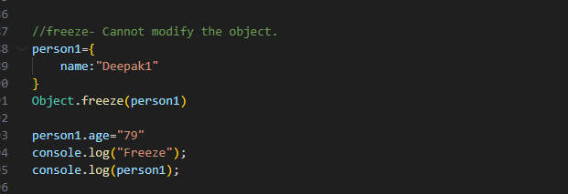
{ name: 'Deepak1' }
Copy Object
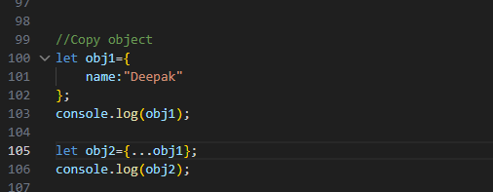
{ name: 'Deepak' }
{ name: 'Deepak' }

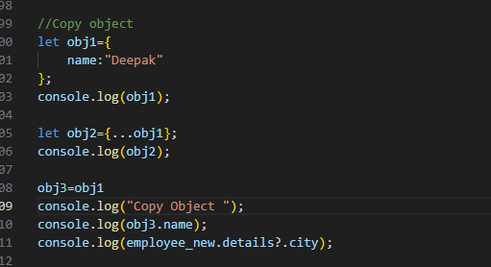
{ name: 'Deepak' }
{ name: 'Deepak' }
Copy Object
Deepak
Undefined

//Object Shorthand
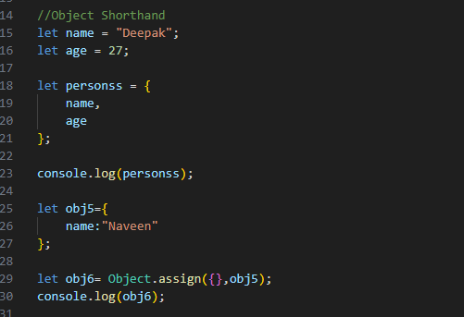
{ name: 'Deepak', age: 27 }
{ name: 'Naveen' }

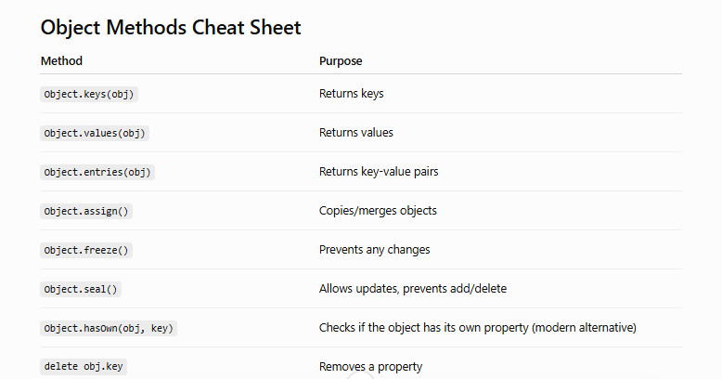

Promises:
A Promise is an object that represents the eventual completion (success) or failure of an asynchronous operation.
There are 3 states in Promise
Pending
Resolved
Rejected
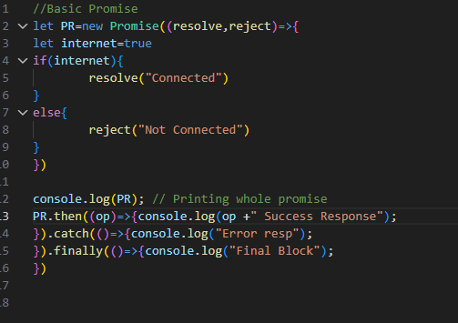
Whole promise: Promise { 'Connected' }
Success Resp: Connected Success Response
Finally : Final Block
If it is Rejected,
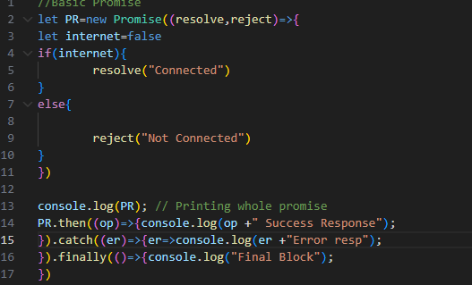
Promise { <rejected> 'Not Connected' }
Final Block

Manual Error throw
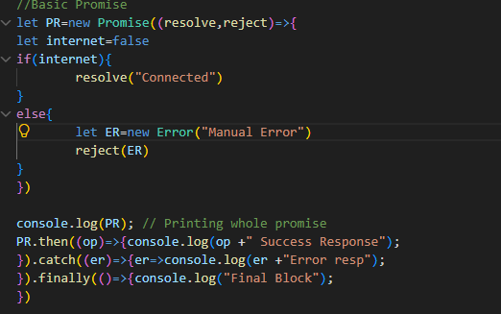
<rejected> Error: Manual Error
Some error codes
Final Block

We can define er.name, er.message, er.stack (Error properties)

Using functions and its return values
Having two functions
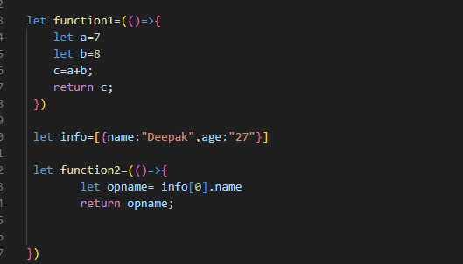

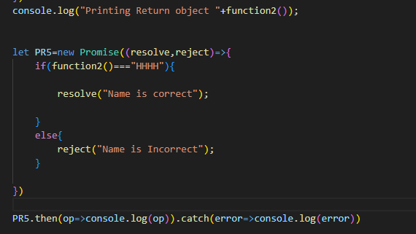
Printing Return object Deepak
Name is Incorrect

Passing Function to the Promise
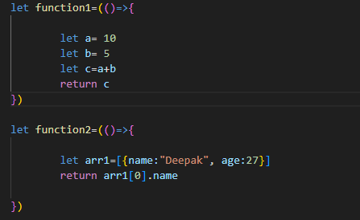
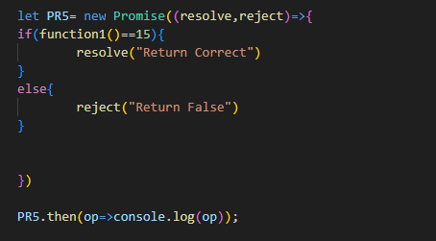
Return Correct

Promise inside Promise
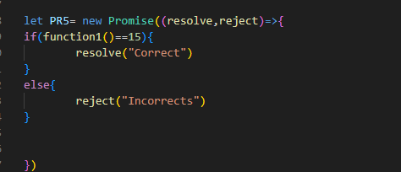

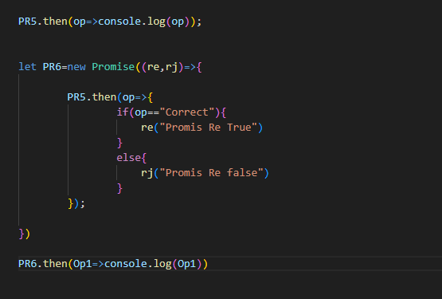
Correct
Promis Re True

Promises methods
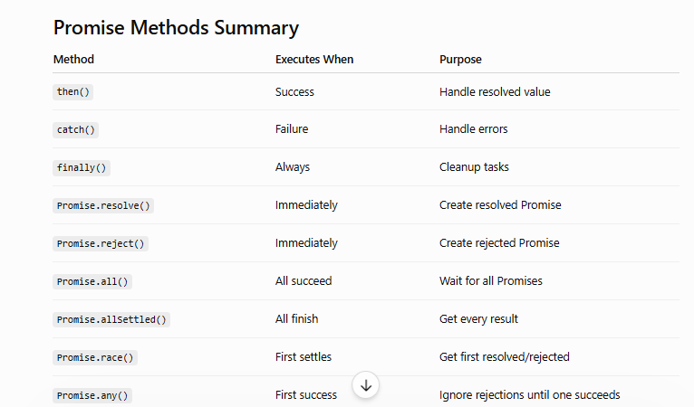

Example of one
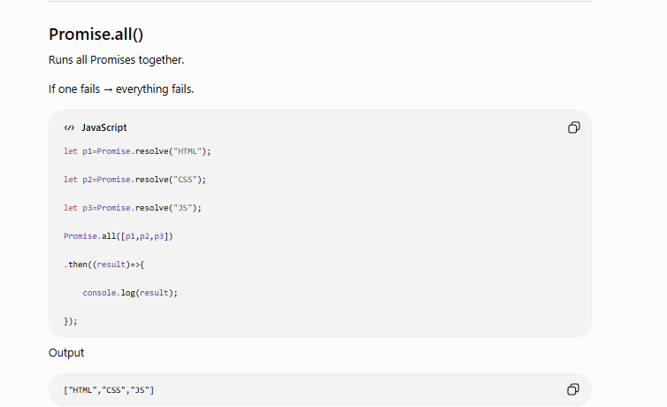

ASYNC and AWAIT
async and await were introduced in ES2017 (ES8) to make asynchronous programming easier.
Instead of writing nested callbacks or multiple .then() chains, we can write asynchronous code that looks like normal synchronous code.

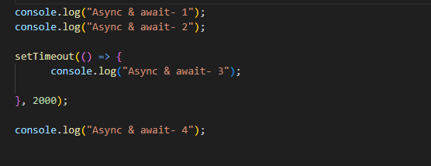
Async & await- 1
Async & await- 2
Async & await- 4
Async & await- 3

To make this async flow to synchronous we are using async function

An async function always returns a promise
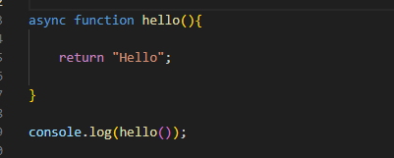
Promise { 'Hello' }
Even though we returned a string,
JavaScript automatically converts it into
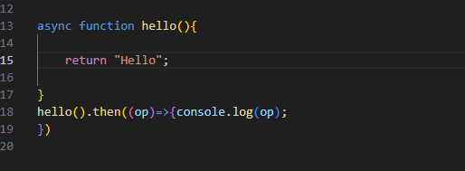

Await:
await waits until a Promise is completed.
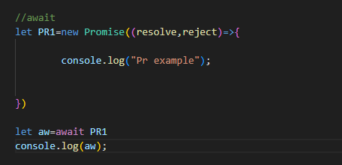
Pr example

It pauses only async function not the entire JS scripts
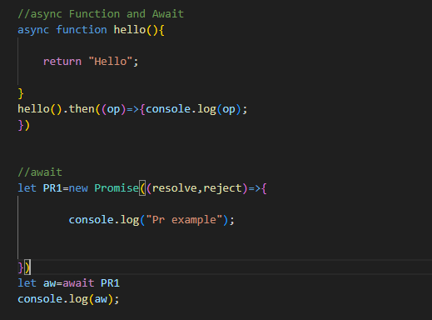
Pr example
Hello

How await works:
Program Starts-> Call async function-> await Promise-> Pause current function-> Other JavaScript continues->Promise completes->Resume function->Execute remaining code

Here we have one Promise that is in await state
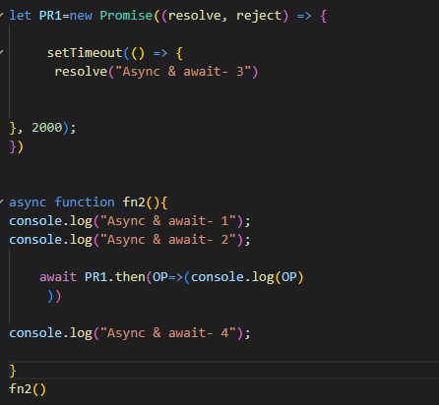
Async & await- 1
Async & await- 2
Async & await- 3
Async & await- 4

We can rewrite line below
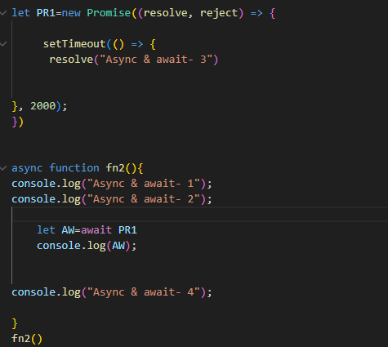
By using function
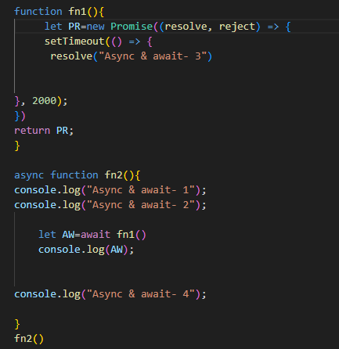

To Handle outside functions
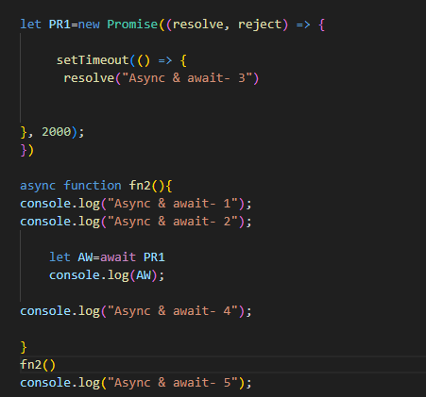
Async & await- 1
Async & await- 2
Async & await- 5
Async & await- 3
Async & await- 4

If we want print in Order use below solutions
Sol 1:
Async function always return a Promise, so using promise chaining we are calling fn2
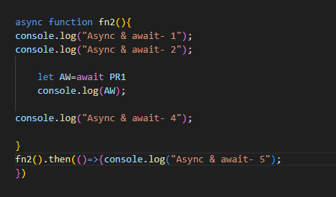

Sol 2: create another async function (fn3()) inside that make it fn2() as await(since it returns promise), then call fn3()
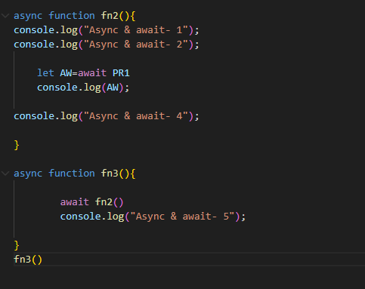
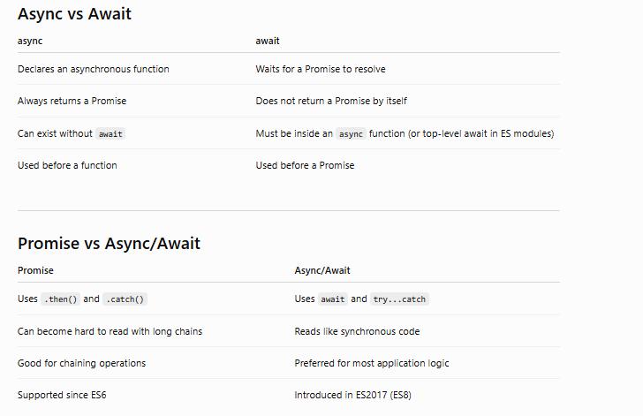
Interview Questions
1. What does async do?
It declares an asynchronous function and automatically wraps its return value in a Promise.
2. Can an async function return a normal value?
Yes. JavaScript automatically converts it into a resolved Promise.
3. Can we use await without async?
Generally no. await must be inside an async function (except top-level await in ES modules).
4. Does await block the whole program?
No. It only pauses the execution of the current async function. Other JavaScript continues running.
5. How do you handle errors with await?
Use try...catch, or handle the returned Promise with .catch().
6. When should you use Promise.all()?
When multiple independent asynchronous tasks can run in parallel, improving performance.
7. Why is async/await preferred over .then()?
Because it produces cleaner, more readable code that resembles synchronous logic and is easier to maintain.

Key Takeaways
- async makes a function return a Promise.
- await waits for a Promise to resolve or reject.
- await pauses only the current async function.
- Use try...catch to handle errors with await.
- Use Promise.all() to execute independent async tasks in parallel.
- Most modern JavaScript frameworks, including Playwright, rely heavily on async/await. Mastering these concepts is essential for writing reliable automation scripts.

Interview Questions
1. What is synchronous code?
Code that executes one statement at a time, where each statement waits for the previous one to complete.
2. What is asynchronous code?
Code that starts a time-consuming operation without blocking the rest of the program. The result is handled later when it's ready.
3. Does await make JavaScript synchronous?
No. It only pauses the current async function. The JavaScript engine continues executing other available code.
4. Give examples of asynchronous operations.
- setTimeout()
- setInterval()
- fetch()
- Promises
- async/await
- Reading files (Node.js)
- Database queries
- Network/API requests

Key Takeaways
- Synchronous = Wait for each task before moving to the next.
- Asynchronous = Start a task, continue with other work, and handle the result later.
- JavaScript is single-threaded, but it can perform asynchronous operations using the Event Loop, Web APIs/Node APIs, and Promise mechanisms.
- async/await makes asynchronous code easier to read, but it does not change it into synchronous code. It only changes how you write and structure asynchronous logic.

CLASS
A class is a blueprint/template for creating objects.
Instead of creating multiple similar objects manually, we create one class and generate many objects from it.

Class with one method, calling that method by creating object
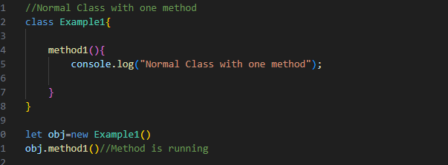
Normal Class with one method

Constructor
Constructor is a special function.
It runs automatically whenever an object is created.
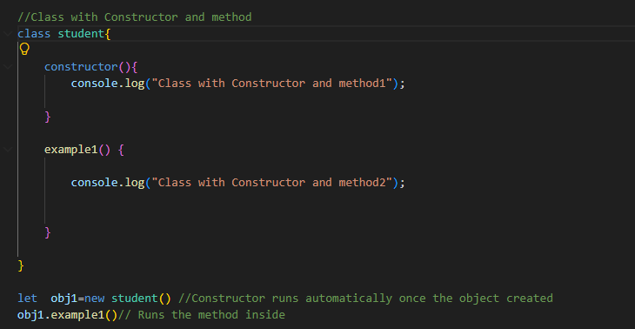
Class with Constructor and method1
Class with Constructor and method2
Parameterized Constructor
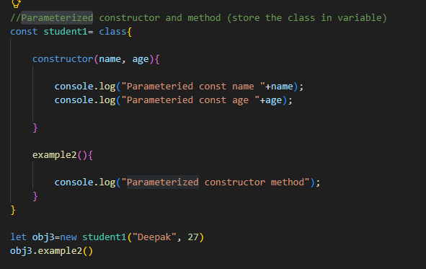
Parameteried const name Deepak
Parameteried const age 27
Parameterized constructor method

Class Declaration
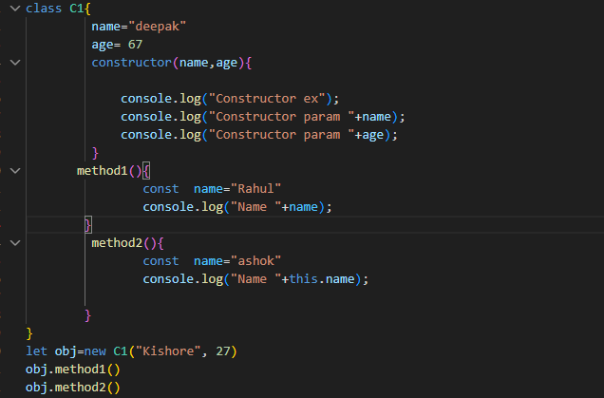
Constructor ex
Constructor param Kishore
Constructor param 27
Name Rahul
Name Deepak (Using “.this” it printing declared inputs inside the class)

THIS
this refers to the object that is currently executing the function.
"this points to whoever is calling the function."
It does NOT refer to where the function is written.
It depends on how the function is called.

Example 1:
With Object and Methods- Declaring variables outside the Method
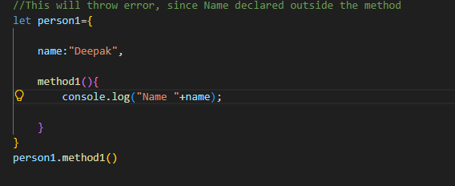
ReferenceError: name is not defined
After using this,
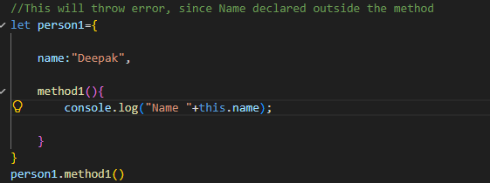
Name Deepak
Example 2:
this.name= person1.name
if we declared outside the object then it will print the Name
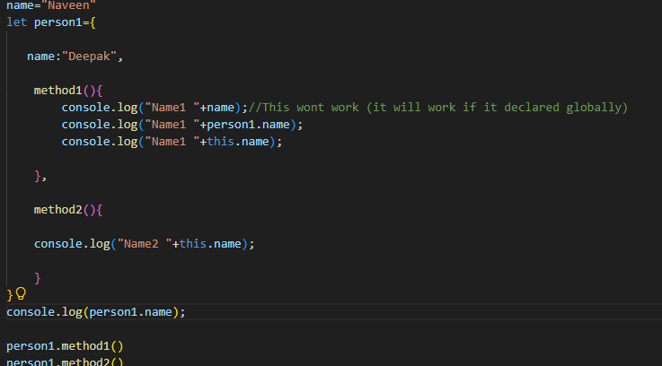
Deepak
Name1 Naveen
Name1 Deepak
Name1 Deepak
Name2 Deepak
Example 3: Using class and Methods (Outside and Inside Declaration)
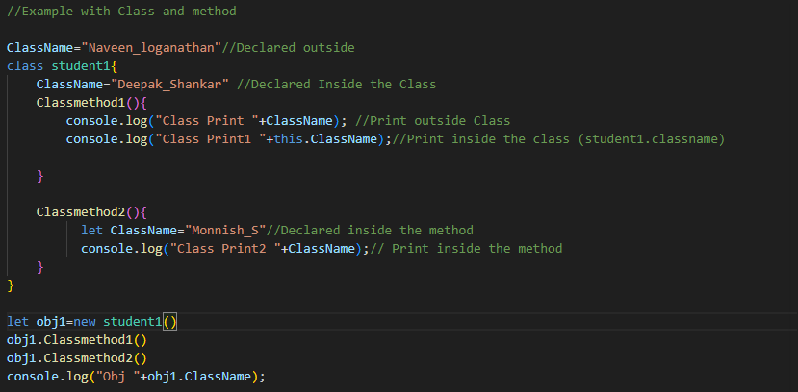
Class Print Naveen_loganathan
Class Print1 Deepak_Shankar
Class Print2 Monnish_S
Obj Deepak_Shankar

Same Deals with Constructor
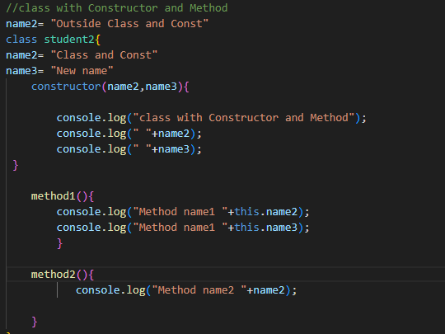
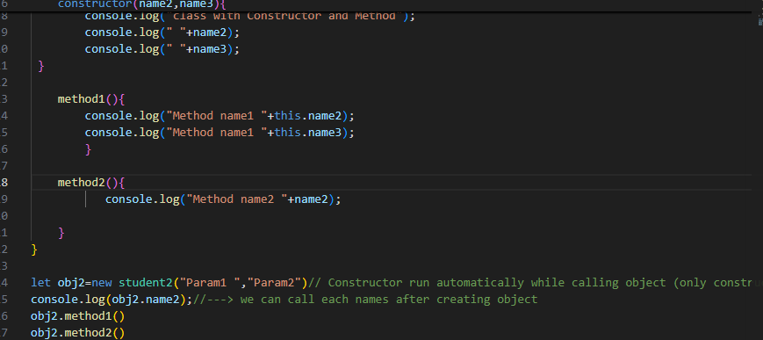
class with Constructor and Method
Param1
Param2
Class and Const
Method name1 Class and Const
Method name1 New name
Method name2 Outside Class and Const

Rules: To print variables based on Declaration
1.If Declared outside the Class Use without this
2.If Declared inside the Class Use with this
3.If Declared inside the method Use without this
4.It will give a priority for declared inside the methods if it is not present the check outside the class

Using Functions
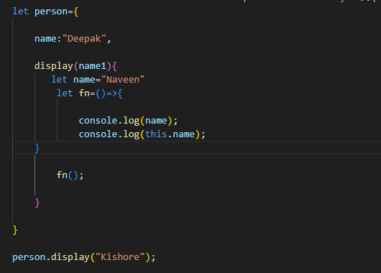
Naveen
Deepak
Ashok

Template Literals
Template Literals (also called Template Strings) were introduced in ES6 (ECMAScript 2015).
Instead of using single quotes (' ') or double quotes (" "), template literals use backticks ( ).

Example 1: Instead of Printing Using + we are using Literals `${}`
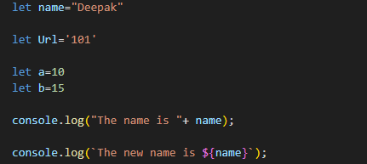
The name is Deepak
The new name is Deepak

Example 2:
Using Expression & Operators
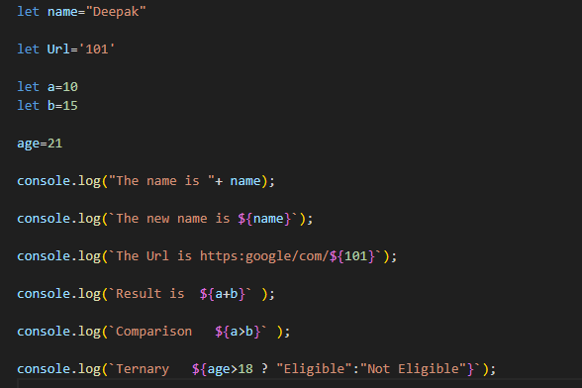

The name is Deepak
The new name is Deepak
The Url is https:google/com/101
Result is 25
Comparison false
Ternary Eligible

Example 3:
Using Functions & Arrow Functions
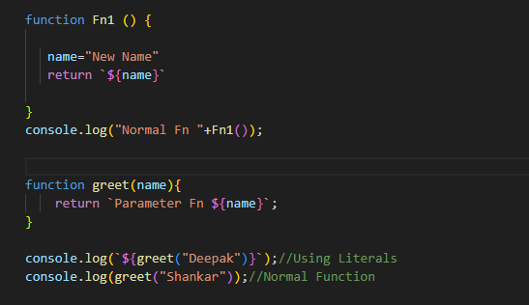
Normal Fn New Name
Parameter Fn Deepak
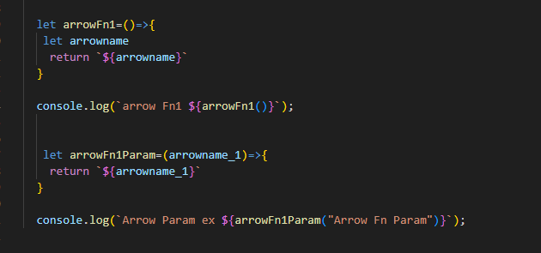
arrow Fn1 undefined
Arrow Param ex Arrow Fn Param

Example 4: Printing Lines
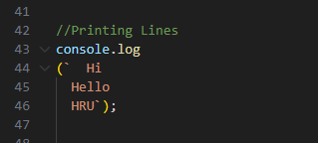
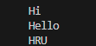

Spread Operators
It is used to expand (spread) elements of an array, object, or iterable into individual values.
Example 1: with Array
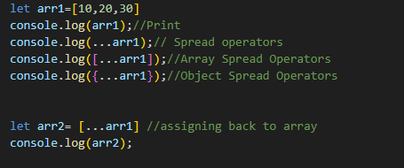
[ 10, 20, 30 ]
10 20 30
[ 10, 20, 30 ]
{ '0': 10, '1': 20, '2': 30 }
[ 10, 20, 30 ]
To add new values
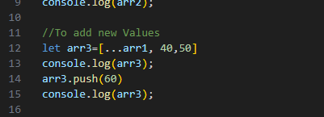
[ 10, 20, 30, 40, 50 ]
[ 10, 20, 30, 40, 50, 60 ]

Example 2: with String
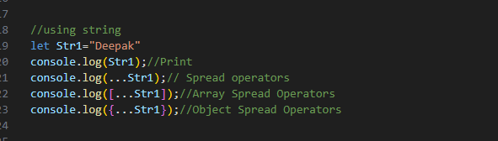
Deepak
D e e p a k
[ 'D', 'e', 'e', 'p', 'a', 'k' ]
{ '0': 'D', '1': 'e', '2': 'e', '3': 'p', '4': 'a', '5': 'k' }
Example 3: Using Object
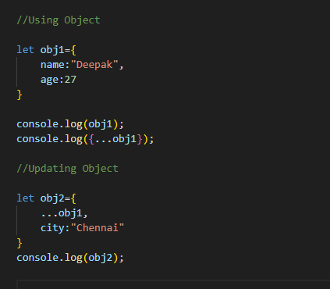
{ name: 'Deepak', age: 27 }
{ name: 'Deepak', age: 27 }
{ name: 'Deepak', age: 27, city: 'Chennai' }

Example 4: Using Functions
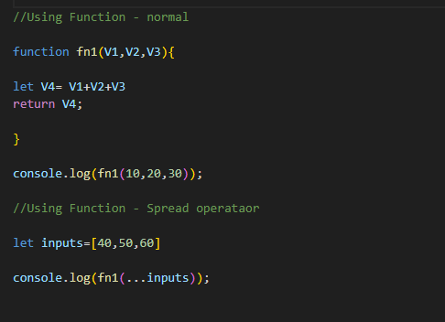
60
150

Destructuring
Destructuring is an ES6 feature that allows you to extract values from arrays or properties from objects and store them into variables in a shorter, cleaner way.
Instead of accessing values one by one, you can unpack them in a single line.
Types of Destructuring
There are mainly two types.
- Array Destructuring
- Object Destructuring

Example1:
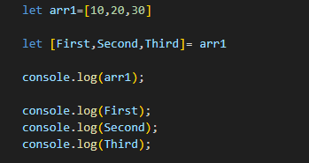
[ 10, 20, 30 ]
10
20
30
Example 2: To Skip
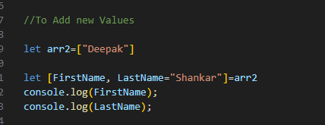
10
30
Example 3: To Add New values
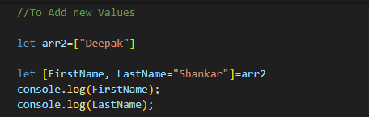
Deepak
Shankar
Example 4: To Swap
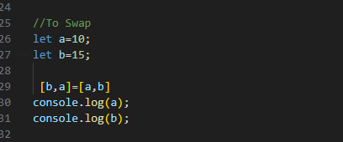
15
10

Example 5: Object Destructuring
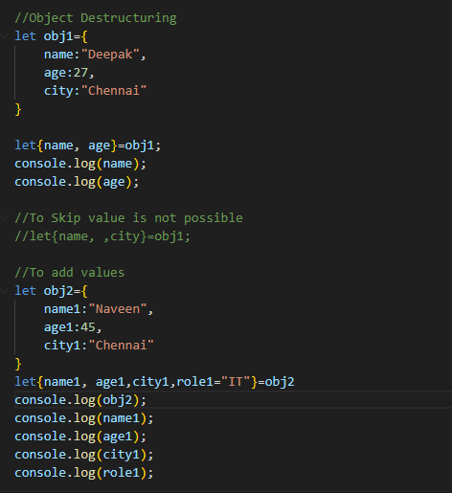
Deepak
27
{ name1: 'Naveen', age1: 45, city1: 'Chennai' }
Naveen
45
Chennai
IT
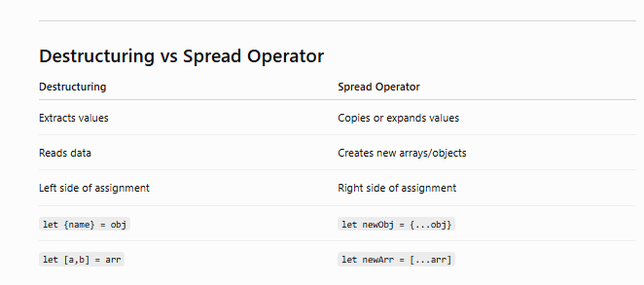

Modules
Instead of writing everything in one file, you can create:
- One file for functions
- One file for variables
- One file for classes
- One file for utilities
- Import them wherever required
This makes the code:
- Cleaner
- Easier to maintain
- Reusable
- Organized
Import and export Snapshots
Export
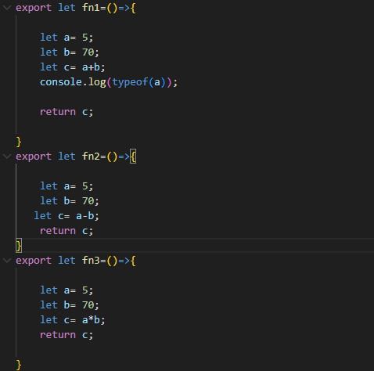
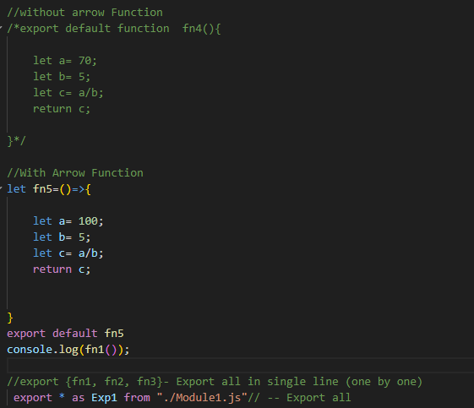

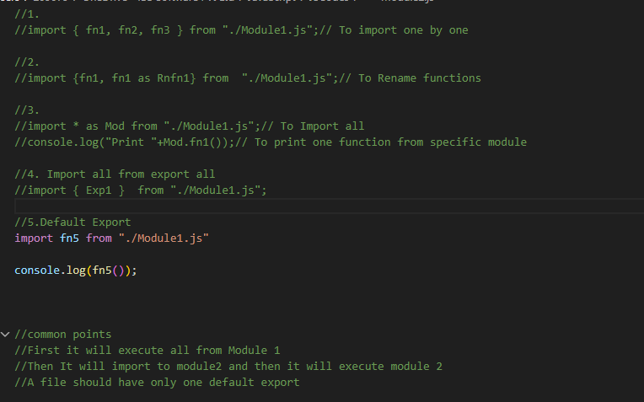

Inheritance
Inheritance allows one class (child class) to acquire the properties and methods of another class (parent class).
Reuse code
Reduce duplicate code
Improve maintainability
Follow DRY Principle (Don't Repeat Yourself)

Example 1: Child class and Parent class
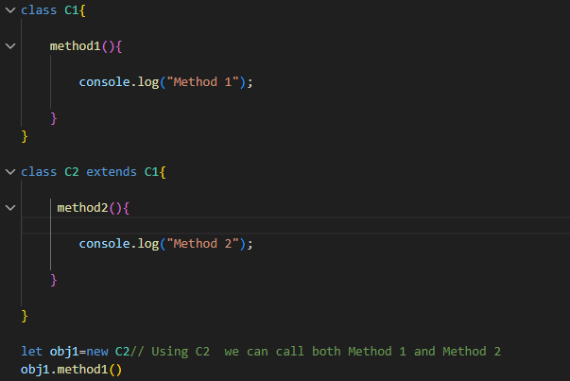
Method 1
Example 2: Using Constructor and Super
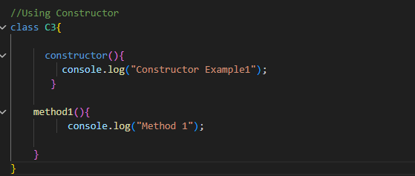
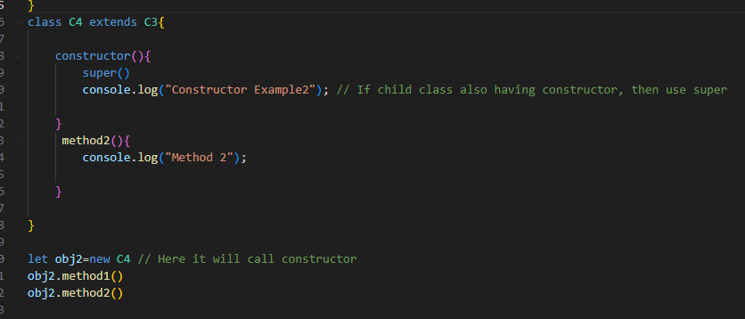
Constructor Example1
Constructor Example2
Method 1
Method 2

Example 3: Using this, constructor, super
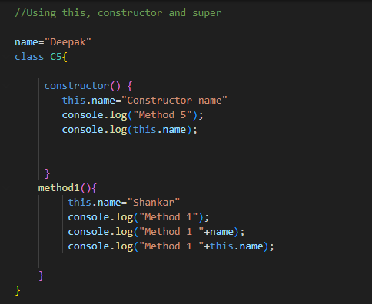
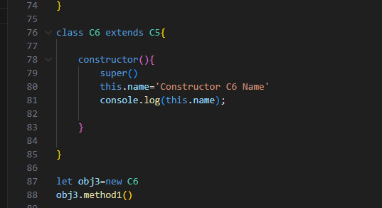

.this- Logic remains same for constructor as well
Output:
Constructor name
Constructor C6 Name
Method 1
Method 1 Deepak
Method 1 Shankar

Example 4: Using this, super, constructor with param
Using Super we can pass the parameter to Parent Constructor

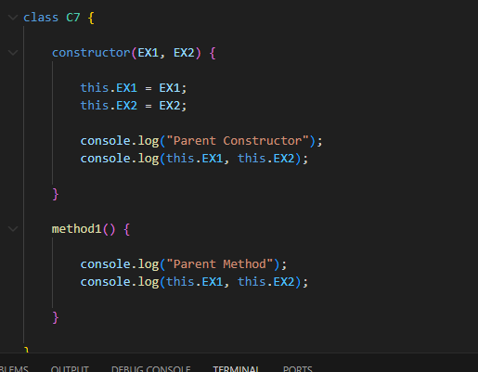
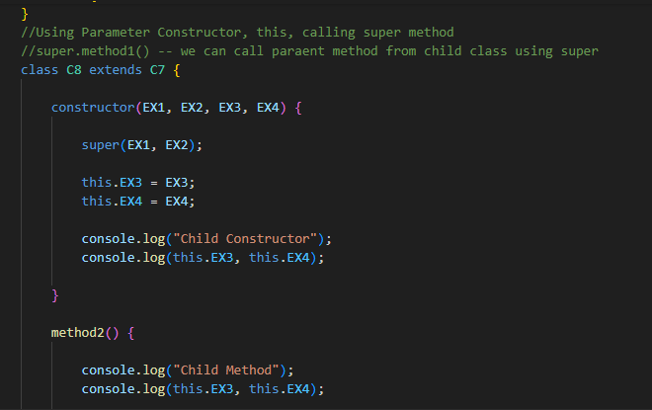
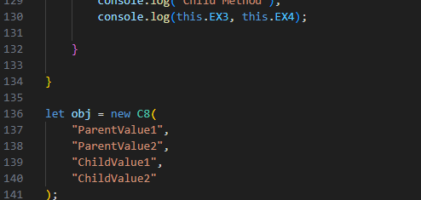
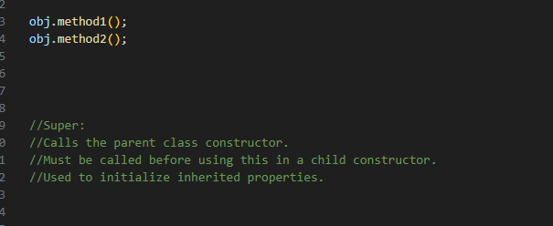
Output:
Parent Constructor
ParentValue1 ParentValue2
Child Constructor
ChildValue1 ChildValue2
Parent Method
ParentValue1 ParentValue2
Child Method
ChildValue1 ChildValue2

Multi-Level Inheritance
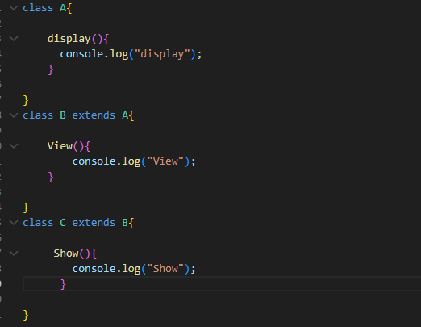
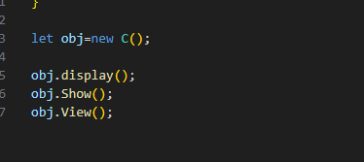
display
Show
View

